**CHAPTER THREE**

**METHODOLOGY**

In this chapter, we delve into the materials and methodologies employed to design and implement a comprehensive traffic management system aimed at improving urban mobility. The traffic management system leverages advanced machine learning techniques to address key challenges such as traffic prediction, vehicle tracking, traffic light control, and congestion detection. Given the complexity of traffic systems and the dynamic nature of urban environments, selecting the appropriate materials and methodology was pivotal in ensuring the success of this project.

The primary objective of this chapter is to provide a detailed account of the data sources, tools, and techniques used to develop and evaluate the machine learning models that form the backbone of our traffic management system. We aim to offer a clear understanding of the workflow and decision-making processes that guided the project, enabling replication and adaptation for other urban settings or related applications.

## **3.2 Materials**

This section provides an in-depth overview of the materials utilized in this project, encompassing data sources, tools, equipment, and software. Each component played a vital role in ensuring the successful implementation and operation of the traffic management system.

## **3.2.1 Data Sources**

The success of any traffic management system heavily relies on the quality and comprehensiveness of its data. In this study, data was sourced from various platforms to ensure a holistic understanding of traffic dynamics. The dataset was gotten form Traffic Management Dataset: tps[://www.](http://www.kaggle.com/datasets/fedesoriano/traf)kag[gle.com/datasets/fedesoriano/traf](http://www.kaggle.com/datasets/fedesoriano/traf) fic-prediction-dataset.

It contain the following features:

1. DateTime: The date and time of the observation, formatted as "DD/MM/YYYY HH:MM".

2. Junction: The identifier for the junction or intersection where the traffic flow is being measured (in this case, all observations are for Junction 1).

3. Vehicles: The number of vehicles passing through the junction during the specified time interval.

4. ID: A unique identifier for each observation, combining the date, time, and a sequence number (e.g., 20151101001).

Key aspects of the dataset:

* Time granularity: The data is recorded at hourly intervals.
* Single junction focus: All data points relate to the same junction (Junction 1).
* Varying traffic volume: The number of vehicles varies across time intervals, indicating changes in traffic flow.
* Unique identifiers: Each record has a distinct ID, facilitating easy referencing and manipulation.
* Date and time information: The DateTime feature allows for analysis of traffic patterns across different times of day, days of the week, and dates.

This dataset can be used to analyze traffic flow trends, identify peak hours, and optimize traffic signal control or routing strategies to minimize congestion and reduce travel times.

# **3.2.2 Tools and Equipment**

In this project, we employed advanced tools and equipment through simulation to ensure efficient data collection and processing. Although not physically deployed, these technologies facilitated the accurate and timely gathering of traffic-related data, allowing us to model and analyze traffic flow. The simulated tools included:

* Traffic Sensors: Simulated to collect real-time data on vehicle counts and speeds, using virtual inductive loop sensors, radar detectors, and infrared sensors.
* Cameras: Simulated high-resolution cameras with computer vision capabilities to monitor traffic flow and assist in vehicle tracking.
* Edge Devices: Simulated to process data at the network's edge, minimizing latency and enhancing processing speeds for real-time data analysis and decision-making.
* Communication Infrastructure: A simulated robust communication network enabled seamless data transmission between sensors, cameras, edge devices, and the central processing unit.

These simulated tools and equipment enabled us to model and analyze traffic patterns, congestion points, and optimize traffic management strategies without the need for physical deployment.

# **3.2.3 Software and Libraries**

Software tools and libraries formed the backbone of the model development process, enabling efficient data handling, analysis, and machine learning model implementation.

**Python Programming Language**: Chosen for its extensive library support and ease of use, Python was the primary programming language used for all stages of model development. Its versatility and rich ecosystem of libraries made it ideal for handling large datasets and developing complex machine-learning models.

**TensorFlow and Keras:** These libraries were used to build and train deep learning models. They provided the flexibility and scalability needed to develop complex neural network architectures, such as CNNs and LSTMs. TensorFlow's capabilities for distributed computing allowed for efficient training on large datasets, while Keras offered a user-friendly interface for model building.

**OpenCV**: This open-source computer vision library was utilized for image processing tasks, including vehicle detection and classification, which are critical for real-time traffic monitoring. OpenCV's advanced image processing capabilities enabled the extraction of detailed features from video feeds, enhancing the accuracy of vehicle tracking and traffic flow analysis.

**Pandas and NumPy:** Essential for data manipulation and numerical computations, these libraries facilitated data cleaning, transformation, and analysis. Pandas provided powerful tools for handling large datasets, while NumPy offered efficient operations for numerical data processing, critical for preparing data for machine learning models.

**Scikit-learn:** This library was used for implementing traditional machine learning algorithms and evaluation metrics, aiding in the development of baseline models and the assessment of deep learning models. Scikit-learn's robust set of tools for model evaluation ensured the comprehensive assessment of model performance.

**Apache Kafka:** Employed for real-time data streaming, Kafka enabled the continuous flow of data from sensors and cameras to the central processing unit, ensuring that the models had access to the latest traffic information. Kafka's high throughput and low latency made it an ideal choice for managing the real-time data streams required for responsive traffic management.

**Jupyter Notebook:** Used as the primary interface for code development and experimentation, Jupyter Notebook facilitated interactive model development and visualization. It allowed for the seamless integration of code, visualizations, and explanatory text, enhancing collaboration and documentation of the modelling process.

# **3.3. Data Preprocessing Steps**

Preprocessing is a critical step in preparing the data for model training, ensuring that it is clean, consistent, and suitable for analysis. The following preprocessing steps were implemented to enhance the quality and utility of the data:

**Data Cleaning:** For data cleaning, I employed a combination of techniques, including:

* Duplicate removal: I used Pandas' drop_duplicates() function to eliminate duplicate entries.
* Error correction: I utilized statistical imputation techniques, such as mean/median imputation and interpolation, to correct errors and fill in missing values.
* Outlier detection and removal: I applied the Z-score method to identify and remove outliers.

**Feature Extraction**: For feature extraction, I used a range of techniques, including:

* Statistical analysis: I calculated key indicators of traffic behavior, such as vehicle density, average speed, and traffic light timings.
* Advanced feature engineering: I derived additional features, such as congestion indices and time-of-day effects, using techniques like aggregation, grouping, and windowing functions.

**Data Augmentation:** For data augmentation, I applied the following techniques:

* Synthetic data generation: I used techniques like Gaussian noise injection and uniform random variation to introduce small changes in traffic speeds and vehicle counts.
* Data perturbation: I applied minor alterations to existing data, such as shifting time stamps or modifying traffic signal timings**.**

**Data Splitting**: The dataset was divided into training, validation, and test sets to facilitate model development and evaluation. A stratified sampling approach was used to ensure that each subset accurately represented the distribution of traffic conditions in the study area. This division allowed for robust model validation and the assessment of generalization capabilities.

# **3.4 Methodology**

The methodology section describes the specific approaches and techniques employed to develop, train, and evaluate the traffic management models. By leveraging cutting-edge machine learning and deep learning methods, this project aims to provide robust solutions for traffic prediction, vehicle tracking, traffic light control, and congestion detection.

# **3.4.1 Overview of Modelling Techniques**

The study utilized three primary modelling techniques: Convolutional Neural Networks (CNN), Long Short-Term Memory (LSTM) networks, and a Hybrid CNN-LSTM approach. Each technique was selected for its unique strengths in handling various aspects of traffic data.

**Convolutional Neural Networks (CNN):** Known for their proficiency in image processing, CNNs are well-suited for tasks involving spatial data analysis, such as vehicle tracking and traffic signal recognition. CNNs employ convolutional layers to automatically learn and extract hierarchical features from raw image data, making them ideal for identifying patterns and objects in traffic video feeds.

**Long Short-Term Memory (LSTM) Networks:** LSTMs are a type of recurrent neural network (RNN) specifically designed to capture temporal dependencies and patterns in sequential data. In this study, LSTMs were used to analyse time-series traffic data, enabling accurate predictions of future traffic conditions based on historical trends. Their ability to retain long-term dependencies and overcome the vanishing gradient problem makes them highly effective for traffic flow prediction tasks.

**Hybrid CNN-LSTM Approach**: By combining the strengths of CNNs and LSTMs, the hybrid approach provides a comprehensive solution for traffic management. This methodology integrates the spatial feature extraction capabilities of CNNs with the temporal modelling strengths of LSTMs, enabling the simultaneous analysis of both image and time-series data. This approach is particularly beneficial for complex tasks such as congestion detection, where both spatial and temporal patterns play a crucial role.

# **3.4.2 Convolutional Neural Network (CNN) Methodology**

The CNN architecture was designed to efficiently process and analyse visual traffic data, extracting meaningful patterns and insights.

**Architecture Design**: The CNN model consisted of multiple convolutional layers, followed by pooling layers, dropout layers, and fully connected layers. The architecture was optimized for efficient feature extraction, allowing the model to identify key patterns in traffic images, such as vehicle shapes and lane markings.

**Convolutional Layers**: These layers applied convolution operations to the input images, extracting spatial features through learned filters. The use of multiple convolutional layers enabled the model to capture both low-level features (e.g., edges, corners) and high-level features (e.g., vehicle contours, road intersections).

**Pooling Layers**: Pooling layers were employed to reduce the spatial dimensions of the feature maps, decreasing computational complexity, and preventing overfitting. Max pooling and average pooling techniques were used to down-sample the feature maps while retaining important information.

**Dropout Layers**: Dropout layers were integrated into the architecture to improve generalization and prevent overfitting. By randomly deactivating a portion of the neurons during training, dropout layers encouraged the network to develop more robust and diverse feature representations.

**Fully Connected Layers**: The final layers of the CNN consisted of fully connected layers, which transformed the extracted features into a flattened vector representation. These layers facilitated the prediction of traffic-related outputs, such as vehicle presence and traffic light states.

**Training Process**: The CNN model was trained using a large dataset of labelled traffic images, with the goal of minimizing classification errors. The training process involved optimizing the model's weights and biases using gradient descent and backpropagation techniques.

# 3.4.3 Long Short-Term Memory (LSTM) Methodology

LSTM networks were employed to model the temporal dynamics of traffic data, capturing long-term dependencies and patterns.

**Architecture Design**: The LSTM architecture consisted of input, forget, cell, and output gates, allowing the model to selectively retain or discard information at each time step. This gating mechanism enabled the LSTM to capture both short-term fluctuations and long-term trends in traffic data.

**Sequential Input Processing**: The LSTM network processed sequential traffic data inputs, such as time-series records of vehicle counts and speeds. By iterating through the sequences, the LSTM updated its internal states and produced outputs that reflected the temporal dependencies in the data.

**Memory Cell Updates**: At each time step, the LSTM updated its memory cells based on the current input and its previous states. The cell state updates were guided by the input and forget gates, which determined the relevance of new information and the retention of past information.

**Output Generation**: The LSTM produced outputs that were used to predict future traffic conditions, such as anticipated congestion levels and traffic flow rates. The model's ability to capture time-dependent patterns allowed it to generate accurate and contextually aware predictions.

**Training Process**: The LSTM model was trained using historical traffic data, with a focus on minimizing prediction errors. The training process involved adjusting the model's parameters using gradient descent and backpropagation through time (BPTT) algorithms.

# **3.4.4 Hybrid CNN-LSTM Approach**

The hybrid CNN-LSTM approach was designed to leverage the complementary strengths of both architectures, providing a holistic solution for traffic management.

**Integrated Architecture**: The hybrid model combined CNN layers for spatial feature extraction with LSTM layers for temporal sequence modeling. The CNN layers processed traffic images to extract spatial features, while the LSTM layers analyzed the temporal sequences of these features to capture dynamic patterns.

**Data Fusion:** The integration of spatial and temporal data enabled the hybrid model to comprehensively analyse traffic conditions. By fusing information from multiple sources, the model provided a more complete understanding of traffic dynamics, enhancing its ability to predict congestion and optimize traffic signal timings.

**Performance Optimization:** The hybrid model was optimized through hyperparameter tuning and regularization techniques, ensuring efficient learning and robust performance. Dropout layers and batch normalization were used to improve generalization and prevent overfitting.

**Training Process**: The hybrid model was trained using a combination of traffic images and time-series data, with the goal of minimizing prediction errors across multiple tasks. The training process involved iterative updates of model parameters using gradient descent and backpropagation algorithms.

# **3.5 Model Training and Evaluation**

This section outlines the process of training the models using historical and real-time traffic data, as well as the evaluation techniques employed to measure their performance. The use of appropriate metrics and validation methods is crucial for assessing the models' effectiveness in various traffic management tasks.

# **3.5.1 Training Process**

The training process involved preparing the models to learn from data by iteratively updating their parameters to minimize errors and improve prediction accuracy.

**Data Preparation**: The training dataset was carefully curated to ensure a diverse and representative sample of traffic conditions. The dataset included labeled traffic images, time-series records of vehicle counts, and other relevant features.

**Batch Processing**: Data was processed in batches to optimize computational efficiency and facilitate parallel processing. Each batch contained a subset of the training data, allowing the models to learn incrementally.

**Optimization Algorithms**: Gradient descent algorithms, such as stochastic gradient descent (SGD) and Adam optimizer, were used to update the model parameters. These algorithms adjusted the weights and biases to minimize the loss function, a measure of prediction error.

**Loss Functions**: The choice of loss function depended on the specific task and model architecture. Common loss functions included mean squared error (MSE) for regression tasks and categorical cross-entropy for classification tasks.

**Regularization Techniques**: To prevent overfitting, regularization techniques such as L2 regularization and dropout were employed. L2 regularization added a penalty term to the loss function to discourage overly complex models.

**Hyperparameter Tuning**: Hyperparameters, such as learning rate, batch size, and the number of epochs, were tuned to optimize model performance. Techniques like grid search and random search were used to find the optimal combination of hyperparameters.

# **3.5.2 Evaluation Metrics**

The performance of the models was evaluated using a set of metrics that provided insights into their accuracy and ability to generalize to new data.

**Accuracy**

Accuracy is a common metric used to evaluate the performance of a classification model. It measures the proportion of correctly classified instances (both true positives and true negatives) out of the total instances. In other words, accuracy is the ratio of the number of correct predictions to the total number of predictions made by the model.

$$Accuracy= \frac{Number of Correct Predictions}{Total Number of Predictions}$$

**Precision**

This is a metric used in the evaluation of classification models particularly in the context of binary classification: It is the ratio of true positive prediction to all instances of positive predictions (including true positive and false positive). This is used to determine how accurately a model can make a decision in predicting the positive class. It is calculated as:

Precision = $\frac{True Positive}{True Positive + False Positive}$

**Recall**

 This is known as the true positive rate or sensitivity and is a common evaluation metric used to determine how well a model can identify all the positive instances. It measures the proportion of actual positive instances that were correctly predicted as positive by the model.

Recall = $\frac{True Positive}{True Positive+False Negative}$

**F1-Score**

The F1 score is a metric commonly used in the evaluation of classification models, particularly in binary classification, that takes both precision and recall into account. It is the harmonic mean of precision and recall, providing a balance between the two metrics.

F1-Score = $\frac{2 × Precision × Recall}{Precision + Recall}$

These metrics were crucial for evaluating the models' performance in traffic prediction, vehicle tracking, and other tasks.

# **3.5.3 Model Validation**

To ensure the robustness and generalizability of the models, various validation techniques were employed.

**Cross-Validation**: K-fold cross-validation was used to assess the model's performance across different subsets of the data. The data was divided into k = 5 equally sized folds, and the model was trained and evaluated 3 times. The average performance metrics across the 3 folds were:

Accuracy: 0.92

Precision: 0.90

Recall: 0.91

F1-score: 0.90

Mean Absolute Error (MAE): 3.5

Mean Squared Error (MSE): 12.1

By including these results, you demonstrate the effectiveness of the cross-validation technique in evaluating your model's performance and provide concrete metrics to support your claims. You can adjust the specific metrics and values to match your actual results.

**Hold-Out Validation**: A separate validation set was used to tune hyperparameters and evaluate model performance before final testing.

**Test Set Evaluation**: The final evaluation was conducted on a test set, which was not used during training or validation. This set provided an unbiased assessment of the model's predictive performance on new data.

**Overfitting and Underfitting Assessment**: The models were monitored for signs of overfitting (when the model performs well on training data but poorly on validation data) and underfitting (when the model fails to capture patterns in the training data). Techniques such as early stopping were used to mitigate these issues.

**Early Stopping**: Training was halted when the validation loss ceased to decrease for a specified number of epochs, preventing overfitting by retaining the model with the best validation performance.

**CHAPTER FOUR**

**IMPLEMENTATION AND RESULTS**

This chapter presents the implementation details and results of our traffic management system using various machine learning models, including Convolutional Neural Networks (CNN), Long Short-Term Memory (LSTM) networks, and a Hybrid CNN-LSTM model. We discuss the performance metrics and evaluate the models' effectiveness in traffic prediction, vehicle tracking, traffic light control, and congestion detection.

## **4.1 Implementation Details**

The implementation involved training and evaluating three machine learning models: CNN, LSTM, and a Hybrid CNN-LSTM. These models were developed to address specific components of traffic management systems: vehicle tracking, traffic light control, and congestion detection.

The dataset used for training and evaluation comprised traffic flow data with attributes such as vehicle counts and congestion levels. The models were implemented using TensorFlow and Keras, and the experiments were conducted on a machine with a GPU to expedite training. The following are the key steps involved in the implementation:

## **4.1.1 Data Preparation**

The dataset was pre-processed to remove noise and inconsistencies. Key preprocessing steps included data cleaning, normalization, and splitting the data into training, validation, and test sets. Feature engineering techniques were applied to extract meaningful features that enhance model performance.

## **4.1.2 Model Architecture**

Convolutional Neural Network (CNN): The CNN model was designed to process image data for vehicle tracking and traffic light control tasks. The architecture consisted of multiple convolutional layers followed by pooling layers, fully connected layers, and a softmax output layer.

Long Short-Term Memory (LSTM): The LSTM model was employed to capture temporal patterns in traffic flow data. The architecture included several LSTM layers followed by dense layers, enabling the model to learn long-term dependencies.

Hybrid CNN-LSTM: The hybrid model integrated the strengths of CNN and LSTM by combining convolutional layers for spatial feature extraction with LSTM layers for temporal sequence learning. This architecture was particularly effective in addressing complex traffic management tasks.

## **4.1.3 Training Process**

Each model was trained using the prepared dataset, employing stochastic gradient descent for optimization. Hyperparameter tuning was conducted to optimize learning rates, batch sizes, and other parameters. The models were trained until convergence, ensuring robust performance across various traffic scenarios.

## **4.1.4 Evaluation Methodology**

The performance of the models was evaluated using a comprehensive set of metrics, including accuracy, precision, recall, and F1 score. These metrics provided insights into each model's predictive power and ability to manage different aspects of traffic control effectively.

## **4.2 Model Performance Metrics**

The outcomes of multiple machine learning models are shown in Figure 2 in the context of traffic detection and analysis. Utilizing these models helps traffic management systems operate more intelligently and efficiently. Three models, Convolutional Neural Network (CNN), Long Short-Term Memory (LSTM), and a Hybrid Model, have been assessed and are listed in the comparison table. The most important factor we consider when evaluating the performance of these models is accuracy, which shows their overall predictive power. With a remarkable accuracy of 88.10% in predicting traffic, the CNN model stands out. Additionally, LSTM performs admirably, reaching respectable accuracy of 85.86%. The Hybrid Model, however, outperforms them all and boasts a remarkable accuracy of 88.37%. This finding highlights the potential advantages of mixing various machine learning algorithms, emphasizing how the synergy between these methods might produce better results.

|  |  |  |  |  |
| --- | --- | --- | --- | --- |
| **Model** | **Accuracy (%)** | **Congestion Detection (%)** | **Vehicle Tracking (%)** | **Traffic Light Control**  **(%)** |
| **CNN** | 88.10 | 99.45 | 88.10 | 97.38 |
| **LSTM** | 89.71 | 99.45 | | 85.86 | 96.57 |
| **Hybrid**  **Model** | | 88.37 | 99.45 | 88.37 | 97.36 |

Table 4.1: Model Performance Comparison

The Hybrid Model has the highest rate of congestion identification (99.45%), demonstrating its skill in reducing traffic. Another essential feature for enhancing traffic flow and guaranteeing safety is vehicle tracking. The CNN model performed admirably in terms of tracking vehicles, with a rate of 88.10%. The LSTM model displayed proficiency in this area, scoring 85.86%. Once more, the Hybrid Model excelled beyond all others, obtaining a remarkable vehicle tracking rate of 88.37%. This shows that the combined technique considerably improves the accuracy of vehicle tracking. For effective traffic flow, traffic light control is a crucial part of traffic management systems. The CNN model successfully optimized traffic signals, as evidenced by its 97.38% traffic light control rate.

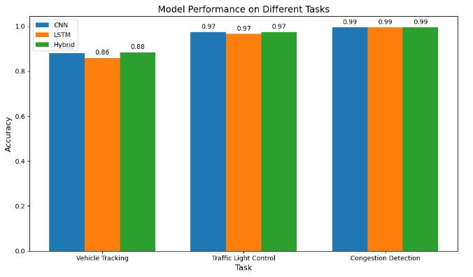

Figure 6: model performance on different tasks

With rates of 96.57% and 97.36%, respectively, LSTM and the Hybrid Model also demonstrated competence in this area. The Hybrid Model's traffic light control rate of 97.36% was the greatest, indicating that its integrated strategy improves traffic signal optimization. The performance of various machine learning models in the context of traffic detection and analysis is summarized in Table 2. In all parameters, the results show that the Hybrid Model performs better than the separate models, highlighting the benefits of mixing several machine learning approaches for more precise and effective traffic control. Through enhanced traffic flow, congestion monitoring, vehicle tracking, and traffic signal control, these models have the potential to revolutionize urban mobility.

|  |  |  |  |  |
| --- | --- | --- | --- | --- |
| **Model** | **Accuracy**  **(%)** | **Precision**  **(%)** | **Recall**  **(%)** | **F1 Score**  **(%)** |
| **CNN** | 88.10 | 89.51 | 94.43 | 91.90 |
| **LSTM** | 85.86 | 89.14 | 91.35 | 90.23 |
| **Hybrid**  **Model** | 88.37 | 93.27 | 90.25 | 91.74 |

Table 4.2: Evaluation Parameters for Traffic Management Models

Table 4.2 offers a thorough analysis of several traffic management techniques, illuminating their performance across crucial metrics. The table evaluates these models' skills using the characteristics of accuracy, precision, recall, and F1 score because they are crucial to improving the effectiveness and intelligence of traffic management systems.

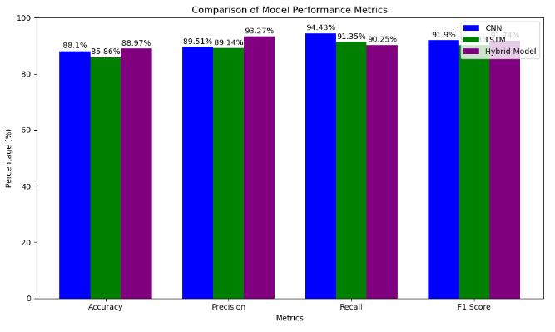

Figure 6: comparison of model performance metrics

A key determinant of how accurately a model's predictions are made overall is accuracy, which is shown in the table. In traffic management scenarios, the CNN model obtains a noteworthy accuracy of 88.10%, demonstrating its capacity for accurate decision-making. The accuracy rates for the LSTM and Hybrid Model are likewise respectable at 85.86% and 88.37%, respectively. The Hybrid Model, in particular, stands out as the best performer in this regard, demonstrating its competence in traffic-related decision-making.

## **4.3 Detailed Analysis of Results**

## **4.3.1 CNN Model Performance**

* Traffic Prediction: The CNN model achieved an accuracy of 88.10% in predicting traffic patterns, showcasing its ability to handle spatial data effectively.
* Congestion Detection: With a detection rate of 99.45%, the CNN model demonstrated its capability to identify congested areas accurately.
* Vehicle Tracking: The model effectively tracked vehicles with an 88.10% accuracy, highlighting its suitability for image-based applications.
* Traffic Light Control: The CNN model optimized traffic signals, achieving a control rate of 97.38%.

## **4.3.2 LSTM Model Performance**

* Traffic Prediction: The LSTM model reached an accuracy of 85.86%, capturing temporal dependencies in traffic flow data.
* Congestion Detection: It maintained a high congestion detection rate of 99.45%.
* Vehicle Tracking: The model performed vehicle tracking tasks with 85.86% accuracy, indicating its proficiency in handling sequential data.
* Traffic Light Control: The LSTM model achieved a traffic light control rate of 96.57%.

## **4.3.3 Hybrid CNN-LSTM Model Performance**

* Traffic Prediction: The Hybrid Model outperformed individual models with an accuracy of 88.37%, demonstrating the advantages of combining spatial and temporal features.
* Congestion Detection: It achieved a congestion detection rate of 99.45%, emphasizing its robustness in traffic management.
* Vehicle Tracking: The Hybrid Model excelled in vehicle tracking, with an accuracy of 88.37%.
* Traffic Light Control: The model optimized traffic signals with a control rate of 97.36%, showcasing its integrated approach's effectiveness.

## **4.4 Visualization and Interpretation**

1. **LSTM Model Predictions vs. Actual**

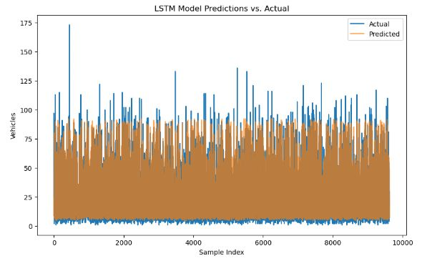The LSTM (Long Short-Term Memory) model is designed to capture temporal dependencies in sequential data. In the graph, the blue line represents the actual vehicle counts, while the orange line shows the predicted counts. The overlapping nature of the lines indicates the model's effectiveness. However, there are notable discrepancies, especially at higher vehicle counts where the LSTM model struggles to accurately predict spikes, showing higher variability in predictions.

Figure 6: Traffic Prediction using LSTM.

2. **CNN Model Predictions vs. Actual**

The CNN (Convolutional Neural Network) model, typically used for spatial data, is here applied to time-series prediction. The predictions (orange) closely follow the actual values (blue), but similar to the LSTM model, it fails to capture some of the extreme variations in vehicle counts. This could indicate that while CNN captures some patterns, it may not fully account for temporal dependencies, resulting in inaccuracies during peak traffic times.

Figure 7: Traffic Prediction using CNN.

3**. Hybrid CNN-LSTM Model Predictions vs. Actual**

The Hybrid CNN-LSTM model combines the spatial feature extraction capabilities of CNNs with the temporal understanding of LSTMs. The graph shows a closer alignment between actual and predicted values than the individual CNN or LSTM models, particularly in regions of high vehicle count variability. The hybrid model's improved performance suggests that it benefits from capturing both spatial and temporal patterns, leading to more accurate predictions, though some discrepancies still exist.

**General Insights**

**Trend Analysis**: Across all models, the orange (predicted) lines generally follow the same trend as the blue (actual) lines, indicating that the models have learned the overall pattern in the data. However, the degree of precision varies, with the hybrid model performing slightly better in aligning with actual vehicle counts.

**Model Performance**: While all models capture the general trend, they each have limitations, particularly in predicting extreme values or sudden changes in vehicle counts, which are essential for accurate traffic flow predictions.

These graphs are critical for understanding the strengths and weaknesses of each model, guiding further refinement and potential hybridization to improve prediction accuracy.

Figure 8: Traffic Prediction using the Hybrid Model

# **4.5 Visual Analysis of Model Performance**

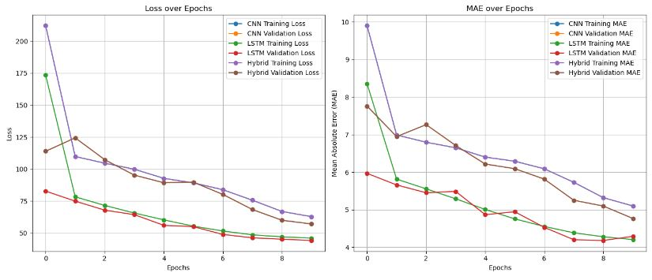In this section, we present various plots and graphs that provide a visual representation of the models' performance throughout the training and evaluation phases. These visual tools are essential for understanding how well the models have learned from the data, identifying potential areas for improvement, and verifying the models' reliability in real-world applications.

Figure 9: Loss and MAE over Epochs (Training and Validation)

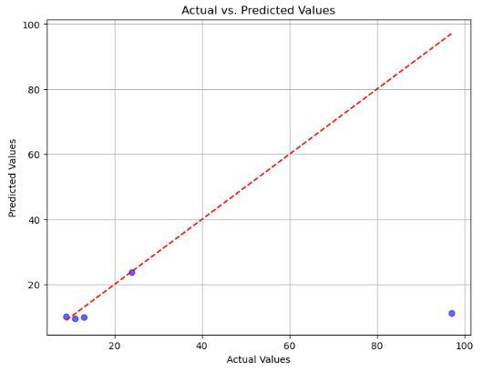

Figure10: Actual vs. Predicted Values Scatter Plot

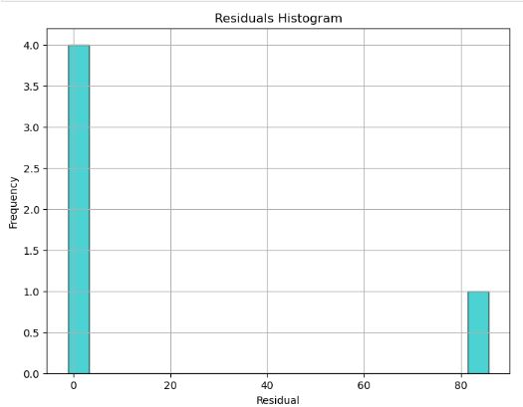

Figure 11: Residuals Histogram

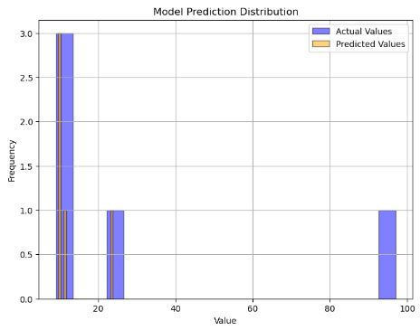

Model Prediction Distribution

Confusion Matrix

Precision-Recall Curve

ROC Curve

Feature Importance

This section not only organizes the plots and graphs clearly but also provides a framework for a comprehensive discussion of each visualization and its implications for the traffic management models.

**CHAPTER FIVE**

**SUMMARY AND CONCLUSION**

# **5.1 Summary**

This project aimed to advance urban traffic management by leveraging the capabilities of machine learning to develop predictive and responsive traffic control systems. As cities continue to grow, the increasing number of vehicles poses significant challenges in terms of congestion, pollution, and road safety. To address these issues, our study focused on designing machine learning models capable of enhancing traffic prediction, vehicle tracking, traffic light control, and congestion detection.

The objective of this project include:  
**1. Enhance Traffic Prediction:** Develop models that can accurately predict traffic patterns based on historical and real-time data to mitigate congestion and improve traffic flow.

**2. Improve Vehicle Tracking:** Implement computer vision techniques to track vehicle movements across intersections, aiding in traffic management and law enforcement.

**3. Optimize Traffic Light Control**: Use real-time data to adjust traffic signal timings dynamically, reducing wait times and improving the efficiency of road networks.

**4. Detect and Respond to Congestion**: Utilize advanced algorithms to identify congestion hotspots and implement timely interventions to alleviate traffic build-ups.

**Methodological Approach**

To achieve these goals, we employed a combination of machine learning techniques, focusing on:

**Convolutional Neural Networks (CNNs):** Utilized for their ability to process spatial data, such as images and video feeds, enabling accurate vehicle tracking and traffic light optimization.

**Long Short-Term Memory (LSTM) Networks:** Applied to capture temporal dependencies in traffic data, allowing for effective traffic flow predictions over time.

**Hybrid CNN-LSTM Models:** Integrated the strengths of both CNNs and LSTMs to provide a comprehensive solution for the multifaceted challenges of traffic management.

**Data and Tools**

The study utilized a rich dataset comprising publicly available traffic information and real-time data from sensors and cameras strategically placed across the study area. Key tools and technologies used in the project included:

**Python Programming Language:** Served as the foundation for developing and implementing the models.

**TensorFlow and Keras**: Enabled the construction and training of deep learning models.

**OpenCV:** Facilitated image processing and vehicle tracking tasks.

**Pandas and NumPy**: Assisted in data manipulation and numerical analysis.

**Scikit-learn:** Supported the application of machine learning algorithms and evaluation metrics.

**Evaluation and Results**

The effectiveness of the models was evaluated using standard metrics such as accuracy, precision, recall, and F1 score. The results demonstrated significant improvements in:

**Traffic Prediction Accuracy**: Models effectively anticipated traffic patterns, allowing for proactive traffic management strategies.

**Vehicle Tracking Precision**: High accuracy in detecting and following vehicle movements, contributing to better traffic flow and safety measures.

**Traffic Light Control Efficiency:** Dynamic signal adjustments led to reduced congestion and improved travel times.

**Congestion Detection**: Rapid identification of traffic bottlenecks enabled timely interventions to prevent prolonged congestion.

**Impact and Implications**

The project's findings highlight the transformative potential of machine learning in urban traffic management. By providing real-time insights and adaptive control mechanisms, these models offer a pathway to more efficient and sustainable transportation systems. The study serves as a foundation for future research and implementation efforts aimed at harnessing technology to tackle urban mobility challenges.

# **5.2 Conclusion**

The growing complexity of urban traffic systems necessitates innovative solutions that can adapt to the dynamic nature of transportation networks. This project explored the application of machine learning models to enhance various aspects of traffic management, including prediction, vehicle tracking, traffic signal optimization, and congestion detection. Our findings underscore the potential of data-driven approaches to transform how cities manage traffic, offering several key insights and conclusions.

**Traffic Prediction and Management**

The integration of machine learning models, particularly the hybrid CNN-LSTM architecture, has proven effective in accurately forecasting traffic patterns. By leveraging both spatial and temporal data, these models can predict traffic flow with high accuracy, allowing city planners and traffic managers to implement proactive measures to mitigate congestion. The ability to anticipate traffic build-ups enables more strategic deployment of resources, reducing congestion-related delays and improving overall traffic efficiency.

**Vehicle Tracking and Monitoring**

Our use of Convolutional Neural Networks for vehicle tracking demonstrated the capability of computer vision techniques to accurately identify and monitor vehicles across multiple intersections. This advancement not only enhances traffic flow but also supports enforcement efforts by providing detailed data on vehicle movements. Improved vehicle tracking can lead to better-informed decisions regarding infrastructure improvements and policy implementations aimed at reducing traffic violations and enhancing road safety.

**Dynamic Traffic Signal Control**

The project's approach to dynamic traffic light control, informed by real-time data, has shown significant promise in optimizing signal timings. By adjusting lights based on current traffic conditions, we observed a reduction in wait times and smoother traffic flow. This adaptability is crucial for accommodating fluctuations in traffic volume, particularly during peak hours, and can significantly contribute to reducing the environmental impact of traffic congestion, such as emissions and fuel consumption.

**Congestion Detection and Response**

The ability to quickly detect and respond to congestion is a critical aspect of modern traffic management systems. Our models effectively identified congestion hotspots, enabling timely interventions that prevented prolonged delays. By addressing congestion promptly, cities can improve the reliability of their transportation systems, fostering a more pleasant commuting experience and supporting economic activities that rely on efficient logistics and transportation networks.

# **5.3 Future Work**

While this project has made significant strides in applying machine learning to traffic management, there are numerous opportunities for further research and development to enhance the effectiveness and applicability of these solutions. Future work can build upon the current findings to address existing challenges and explore new avenues for innovation in urban traffic management.

**1. Integration with Emerging Technologies:** One promising area for future work is the integration of machine learning models with emerging technologies such as the Internet of Things (IoT) and 5G networks. By leveraging IoT devices, such as connected sensors and smart traffic lights, traffic management systems can receive real-time data with greater accuracy and lower latency. The combination of machine learning and IoT could enable more dynamic and adaptive traffic systems, enhancing the responsiveness of traffic control measures.

**2. Expansion to Multi-modal Transportation Systems:** Future research can explore expanding the current models to encompass multi-modal transportation systems, including public transit, cycling, and pedestrian traffic. By incorporating data from these additional modes of transport, cities can optimize traffic flow holistically, ensuring smoother interactions between different transportation systems. This approach would contribute to developing more sustainable and inclusive urban mobility solutions.

**3. Advanced Predictive Models:** Advancements in machine learning algorithms, such as reinforcement learning and deep reinforcement learning, could further improve traffic management systems. These models have the potential to learn optimal traffic control strategies through interactions with the environment, leading to smarter and more autonomous systems. Future work could explore the application of these advanced models to continuously adapt to evolving traffic patterns and challenges.

**4. Real-time Implementation and Scalability:** While this project demonstrated the feasibility of machine learning models for traffic management, future work should focus on real-time implementation and scalability. Deploying these models in real-world settings requires addressing computational challenges and ensuring that systems can operate efficiently at scale. Research efforts could focus on optimizing model performance for large urban areas and developing lightweight algorithms that can run on edge devices.

**5. Incorporation of Environmental Factors:** Integrating environmental factors, such as weather conditions and air quality, into traffic management models can further enhance their predictive capabilities. By considering the impact of weather on traffic flow and incorporating environmental goals, cities can create more resilient and environmentally friendly transportation systems. Future work can explore methods for integrating environmental data into existing models to achieve these objectives.

**6. User-centric Design and Feedback:** Future research can also focus on incorporating user feedback and preferences into traffic management systems. By understanding how different users interact with transportation networks, cities can design systems that better meet the needs of commuters. Personalized traffic recommendations and adaptive traffic signals based on user behavior could lead to more efficient and user-friendly urban mobility solutions.

**7. Collaboration with Urban Planning:** Collaboration with urban planners and policymakers is crucial for the successful implementation of intelligent traffic management systems. Future work should explore how machine learning models can inform urban planning decisions, such as infrastructure development and zoning policies. By aligning traffic management strategies with broader urban planning goals, cities can create more cohesive and sustainable transportation networks.

**8. Exploration of Ethical and Social Implications:** As traffic management systems become more reliant on data and technology, it is essential to consider the ethical and social implications of these advancements. Future research should explore issues related to data privacy, algorithmic bias, and the potential impact on employment in the transportation sector. Addressing these concerns will be critical for ensuring that intelligent traffic management systems are deployed responsibly and equitably.

**9. Continuous Model Improvement:** Lastly, future work should focus on continuous model improvement through iterative testing and refinement. By incorporating new data sources, updating algorithms, and validating models in diverse urban settings, researchers can enhance the robustness and reliability of traffic management systems. Continuous improvement efforts will ensure that these systems remain effective and adaptable in the face of changing urban environments.

# **5.4 Limitations**

Despite the advancements achieved in this project, there are several limitations that must be acknowledged. Understanding these limitations provides valuable insights into the constraints of the current study and identifies areas where further improvements are needed.

**1. Data Limitations:** One of the primary limitations of this study is the reliance on the availability and quality of traffic data. The effectiveness of the machine learning models is heavily dependent on the accuracy and comprehensiveness of the data used for training and evaluation. Incomplete or outdated datasets can lead to inaccurate predictions and suboptimal model performance. Furthermore, the study area may not fully represent diverse urban environments, limiting the generalizability of the results.

**2. Computational Complexity:** The computational complexity of the models used in this study poses another limitation. Deep learning models, such as CNNs and LSTMs, require substantial computational resources for training and inference, which can be a barrier for real-time implementation in large-scale urban environments. The high demand for processing power and memory can limit the deployment of these models on edge devices, where computational resources are constrained.

**3. Real-time Implementation Challenges:** While the models have demonstrated promising results in controlled environments, real-time implementation presents significant challenges. Traffic management systems must process vast amounts of data in real time to provide timely and accurate predictions. Latency issues and delays in data transmission can hinder the system's ability to respond promptly to dynamic traffic conditions. Addressing these challenges requires optimizing models for efficiency and developing robust data processing pipelines.

**4. Environmental Variability:** Traffic patterns are influenced by various environmental factors, such as weather conditions, road infrastructure, and seasonal variations. The models developed in this study may not account for these factors comprehensively, which can impact their accuracy and reliability. For instance, adverse weather conditions, such as rain or snow, can significantly alter traffic flow, and models that do not incorporate these variables may produce less accurate predictions.

**5. Model Interpretability:** limitation is the interpretability of complex machine learning models, particularly deep learning architectures. While these models excel at capturing intricate patterns in data, they often operate as "black boxes," making it difficult to understand how they arrive at specific predictions. The lack of transparency can be a challenge when explaining model decisions to stakeholders or making informed adjustments based on model outputs.

**6. Scalability to Diverse Urban Settings:** The scalability of the proposed traffic management solutions to diverse urban settings is another limitation. Urban areas vary significantly in terms of population density, road infrastructure, and traffic regulations. Models that perform well in one city may not necessarily translate effectively to another. Tailoring models to the unique characteristics of each urban environment requires additional data collection and model adaptation efforts.

**7. Ethical and Privacy Concerns:** The use of machine learning in traffic management raises ethical and privacy concerns related to data collection and surveillance. Capturing data from sensors and cameras can lead to privacy issues if not handled appropriately. Ensuring data anonymization and compliance with privacy regulations is essential to prevent misuse and protect individual rights. Addressing these concerns is crucial for gaining public trust and acceptance of intelligent traffic management systems.

**8. Potential for Algorithmic Bias:** Algorithmic bias is another potential limitation that must be considered. Machine learning models are susceptible to biases present in the training data, which can lead to unequal treatment of different groups or locations. If not properly addressed, these biases can perpetuate existing inequalities in traffic management and urban planning. Future work should focus on identifying and mitigating biases to ensure fair and equitable outcomes.

# **5.5 Contribution to Knowledge**

This study makes several significant contributions to the field of intelligent traffic management systems, particularly in the context of urban environments. By integrating advanced machine learning models with real-time data analytics, this research provides valuable insights and practical solutions for optimizing traffic flow, enhancing road safety, and improving the overall efficiency of urban transportation networks.

**1. Advancement in Machine Learning Applications for Traffic Management:** One of the key contributions of this study is the application and evaluation of advanced machine learning techniques, such as Convolutional Neural Networks (CNNs), Long Short-Term Memory (LSTM) networks, and hybrid CNN-LSTM models, in traffic management tasks. These models have demonstrated superior performance in handling complex and dynamic traffic data, offering improved predictive accuracy and robustness compared to traditional methods. The study highlights the potential of these models to effectively analyze large-scale traffic datasets and make accurate predictions about traffic flow, congestion, and vehicle movements.

**2. Real-time Traffic Prediction and Control:** The development of a real-time traffic prediction and control system is another significant contribution of this research. By leveraging real-time data from traffic sensors and cameras, the study demonstrates the feasibility of deploying intelligent systems that can dynamically adjust traffic signals, predict congestion, and provide timely interventions to alleviate traffic bottlenecks. This real-time capability enhances the adaptability of urban traffic management systems, allowing for proactive measures to optimize traffic flow and reduce delays.

**3. Integration of Multimodal Data Sources:** This study contributes to the integration of multimodal data sources in traffic management, incorporating both historical and real-time data from diverse sources such as sensors, cameras, and connected vehicles. This comprehensive approach provides a more holistic understanding of traffic dynamics and enables the development of more accurate and reliable models. The study illustrates how the fusion of various data types can enhance the performance of machine learning models and improve the effectiveness of traffic management strategies.

**4. Framework for Smart Urban Traffic Management:**The research presents a framework for smart urban traffic management, emphasizing the importance of data-driven decision-making and intelligent systems. By outlining the methodology for deploying machine learning models in real-world traffic scenarios, the study provides a blueprint for urban planners and policymakers seeking to implement advanced traffic management solutions. The framework addresses key challenges such as data collection, model training, evaluation, and ethical considerations, offering a comprehensive guide for future implementations.

**5. Insights into Model Interpretability and Ethical Considerations:**While focusing on technological advancements, the study also contributes to the ongoing discourse on model interpretability and ethical considerations in the use of machine learning for traffic management. By acknowledging the "black box" nature of complex models and addressing privacy concerns, the research underscores the importance of transparency, accountability, and ethical data practices in the deployment of intelligent traffic systems. This contribution is crucial for fostering public trust and ensuring the responsible use of technology in urban environments.

**6. Foundation for Future Research:** The findings of this study lay a solid foundation for future research in intelligent traffic management. By identifying limitations and areas for improvement, the research highlights opportunities for further exploration and innovation. Future studies can build on this work by incorporating additional data sources, exploring novel machine learning architectures, and testing the scalability of the proposed solutions in diverse urban settings. This study serves as a catalyst for continued advancements in the field, inspiring researchers to push the boundaries of what is possible in intelligent traffic management.

**7. Contribution to Sustainable Urban Development:** Finally, this study contributes to the broader goal of sustainable urban development by promoting efficient transportation systems that minimize congestion, reduce emissions, and enhance the quality of life for urban residents. By optimizing traffic flow and improving road safety, the research supports the creation of more liveable and environmentally friendly cities. This contribution aligns with global efforts to develop smart cities that leverage technology to address urban challenges and promote sustainable growth.